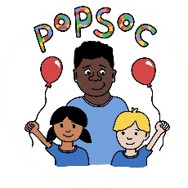
Environmental Policy
Popsoc is committed to the protection of the environment through reducing pollution, emissions and waste.
As part of the induction process, and through staff meetings and training, our staff will be informed about reducing the use of raw materials, supplies and energy.
We raise the children’s awareness of environmental issues through discussions, projects and day-to-day activities within the club.
Children and staff follow the Club’s ‘eco code’:
- We re-use and recycle our waste material, and the recycling bins are easily accessible to staff and children.
- We switch off lights when not in use and fit the lights with energy saving bulbs where possible.
- We turn off electrical equipment at the power source when not in use.
- We turn off taps after use and do not waste water.
- We do not drop litter.
- We plan our outings to minimise vehicle use and use public transport whenever possible.

This policy was adopted by: Popsoc | Date: 04/09/2023
To be reviewed: 04/09/2024 | Signed: K.Thomas

