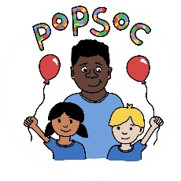
No Platform Policy

Popsoc is committed to providing a safe and caring environment, where children are free from discrimination and protected from abuse, harm and radicalisation. As part of this commitment we aim to ensure that neither our Club sessions nor our premises are used to promote extremist beliefs or discriminatory views.
Key principles
Popsoc will not allow its Club sessions nor its premises to be used:
- To promote or express extremist ideological, religious or political views
- To promote or express discriminatory views in relation to the protected characteristics cited in the Equality Act 2010
- For any reason by an organisation that is proscribed by the Home Secretary under The Terrorism Act 2000.
Definition of terms
Premises: The room, space or building used by the Club while it is running a session
Extremist views: Extremism is defined in the Prevent Strategy as “vocal or active opposition to fundamental British values including democracy, the rule of law, individual liberty and mutual respect and tolerance of different faiths and beliefs. We also include in our definition of extremism, calls for the death of members of the armed forces, whether in this country or overseas.”
Protected characteristics: The characteristics protected under The Equality Act 2010 are:
- Age
- Disability
- Gender reassignment
- Marriage and civil partnership
- Pregnancy and maternity
- Race
- Religion and belief
- Sex
- Sexual orientation
Proscribed organisations: A list of proscribed organisations can be downloaded here: https://www.gov.uk/government/publications/proscribed-terror-groups-or-organisations--2
Related policies
See also: Equalities policy, Safeguarding policy

This policy was adopted by: Popsoc | Date: 04/09/2023
To be reviewed: 04/09/2024 | Signed: K.Thomas
Written in accordance with the Statutory Framework for the Early Years Foundation Stage (2021): Child protection [3.4 – 3.8].

