Popsoc

Parents Handbook
About the club
PopSoc is a 50-place out-of-school club providing year-round care for children aged 4 to 11. We have been running since 1999. PopSoc is registered with Ofsted (Registration No 321481) and is based in Upper Poppleton. The club is open from 7.30am until 8.45am and 3.00pm until 6.00pm weekdays during term. Half terms we open from 8.00am to 5.30pm.
You can download our last inspection report here: 50190075 (ofsted.gov.uk)
We are based in the building next to Poppleton Ousebank Primary School, in The Studio.
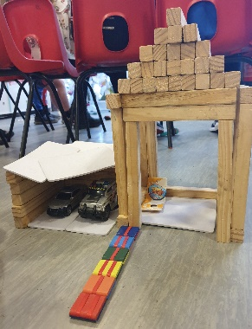
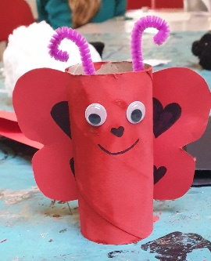
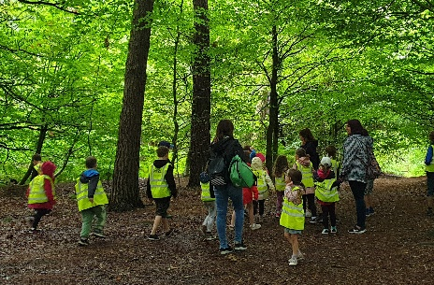
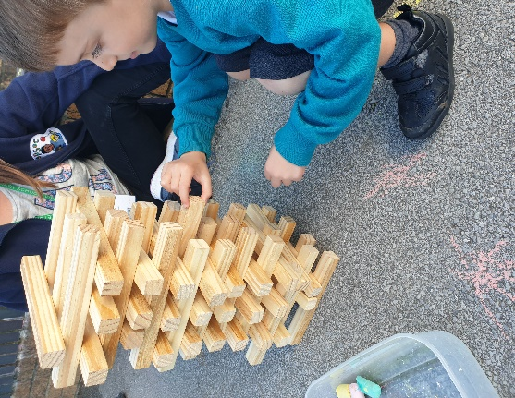

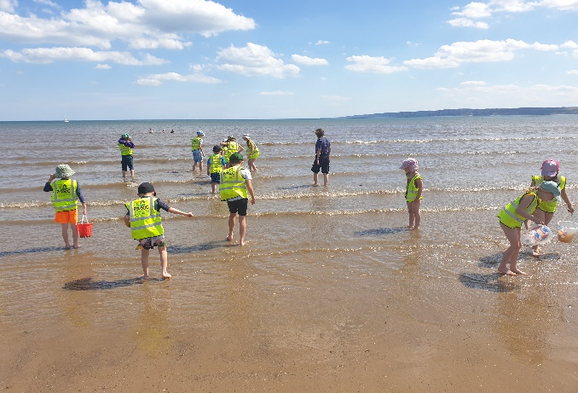
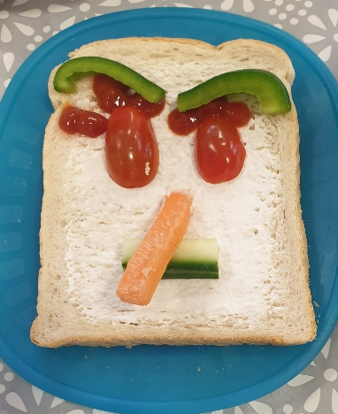

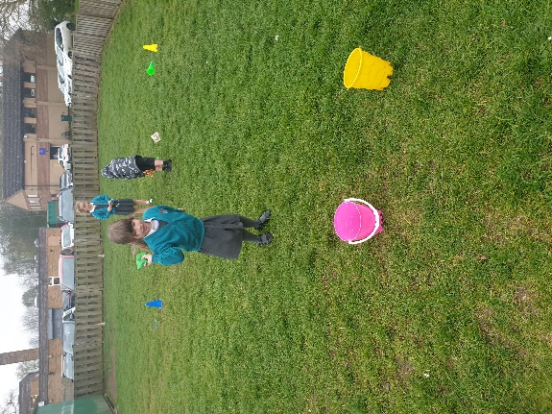
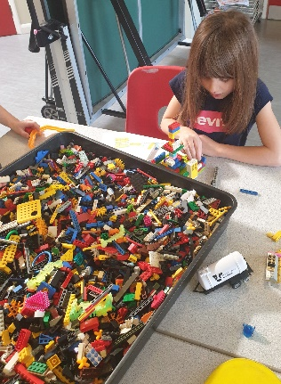
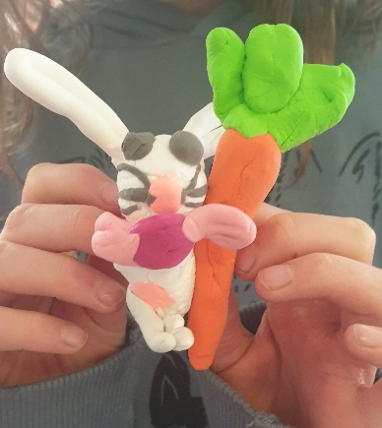

Aims
At PopSoc we aim to provide high quality childcare, a safe, secure and relaxed environment, offering a range of activities to reflect the interests of the children in our care. Our Club follows the Play work Principles, so the children are free to choose activities and resources as they wish. We aim to always have a selection of activities and resources available, including dressing up, home corner, crafts, board games, construction materials, computer games, physical play, cookery, and reading. Free flow play allows children to access our outdoor space.
What we provide
Breakfast/After school Snacks
A wide variety of healthy breakfast options are on offer. Including toast, cereal, yogurts, pancakes, and fruit. The snack we provide at the Club is not intended as a substitute for a main evening meal. We provide healthy snacks, including fresh fruit and vegetables. We use fresh ingredients and follow statutory guidelines. Fresh drinking water is always available. We promote independence, by encouraging the children to prepare their own snacks and to clear away after themselves. We meet individual dietary requirements and parental preferences wherever possible. We recognise the importance of healthy nutrition for children delivered in a calm, friendly setting. We allow children to decide when they are ready to eat, but request that food be consumed whilst sitting at the snack table.
Sessions
Popsoc is committed to providing high quality care, as such all our playworkers hold current First Aid certificates with additional Child Protection, British Values, FGM and Food Hygiene certificates. We have a wide selection of indoor and outdoor equipment and run a range of activities daily. Typical activities include arts and crafts, sports and games, role play, music and drama.
Staffing
Our Club is staffed by a manager Kerri, deputy manager Samantha, supervisor Tracy and 5 playworkers. In addition, we have 3 relief staff. We encourage our staff to obtain Play work-specific qualifications. Currently 1 staff member holds a level 5 in early years leadership and management, 4 of our team have Level 3 Childcare qualifications and 1 staff member training for their level 2 in childcare. The Manager holds a BA Hons in early childhood study. Our Staff are encouraged to reflect on their practice and take steps to improve it, as well as take part in refresher courses. All our staff have significant experience of working with children and undertake professional development training. All staff members have appropriate DBS checks. We maintain a staff/child ratio of 1:8 for children under the age of eight, and a ratio of 1:10 for children over the age of 8. Our aim is to provide a smooth transition between school and club.
If you have a query or concern at any time, please speak to a member of staff at the club when you collect your child. If you prefer to arrange a more convenient time for a meeting, please contact the manager (contact details are at the back of this Handbook).
Organisation
PopSoc is run as a none profit organisation, employing 11 staff. We have a close working relationship with Poppleton Ousebank Primary School in order to ensure continuity of care, and to maintain good communication links. We are run by a voluntary committee; we need a minimum of 6 members to run and to hold a meeting. The committee meet regularly with the manager to discuss the running the club and its financial status. Any changes that are made to the club get voted on and meeting minutes are available. We would like to take this opportunity to invite you to come along to a meeting to get to know how our club works. We hold 6 meetings a year, one of which is the annual general meeting which is usually held in January. It is important for all our users to attend this meeting, for our club to continue to operate. We are always on the lookout for more members, so please ask for more information if this is something you are interested in.

Policies and procedures
The Club has clearly defined policies and procedures. Key points of the main policies are included in this Handbook. Copies of the full policies are kept at the Club and are available on our web page for parents to always consult.
Terms and conditions
Admission
Our Club aims to be accessible to children and families from all sections of our local community. Admission to the club is organised by the Manager and we use a waiting list system when the need arises. The waiting list will be operated on a first come-first served basis, except for siblings who will have priority for the same days as a sibling already attending, if the space is available. We require a completed set of registration forms, a booking form and a signed terms and conditions form, for your child before they can attend the club. This information will be treated as confidential and will be stored appropriately, please sign the attached slip to confirm that we have your permission. Re-enrolment for September is required at the end of the summer term. We cannot keep a place open for your child unless you complete a new booking form.
Payment of fees
The current fees are £5.50 per child per breakfast club session and £10.75 for a after school club session. Fees are payable in advance by bank transfer, Tax-Free Childcare or childcare vouchers.
The Club recognises that childcare can be costly, so we encourage eligible parents or carers to claim the childcare element of the Working Tax Credit/Universal Credit. We accept vouchers from the following childcare voucher schemes [Edenred, code P20081827, Computershare, code 8027320, Care-4, code 54636343, Sodexo, EFC, Fideliti].
The price per session per child applies to all children. This is payable for all booked sessions including when your child is sick or on holiday (unless cancellation within the notice period is given).
We do not charge for bank holidays and professional training days.
Please ensure that fees are paid promptly. Non-payment for more than one month may result in your place being terminated. If you are having difficulty paying fees, please speak in confidence to the Manager.
Changes to days and cancelling your place
You must give us 14 day’s notice of termination or of changes in attendance. 14 full days notices are required, Day 1 of your notice will begin the day after your notice has been handed in. If you need to change the days that your child attends, please contact the Manager. We try to accommodate such changes wherever possible.
As of 6th of November 2023, if you request the cancellation of 5 days per term, in 2 consecutive terms, PopSoc will initiate discussions with you to understand your requirements for wrap around care in so that we can provide the right balance between your needs and PopSoc's commitment to support the local community. We will attempt to organise a telephone review during PopSoc opening hours on a maximum of 3 occasions. Failure to attend a review may result in a reduction of days or the cessation of our provision to provide you with wrap around care.
As ever, we will always take each case in to account individually and make sure that existing children have the correct sessions for their needs.

Temporary changes
Please remember that we need to know if your child will not be attending the Club for any reason. Even if you have informed your child's school, you still need to notify us as the school does not pass this information on to us. If your child doesn’t attend a booked session, we will have to treat them as a ‘missing child’ unless you have notified us of their absence.
If you know in advance of any days when your child will not be attending during the following week, please try to let the Manager know. In cases of illness or emergency when notice cannot be given, please call as soon as you can. Contact details can be found at the end of this Handbook.
For after school activities, i.e.Tennis, Football, Total sports, where you require your child dropping off or collected from, please inform us of ANY changes as soon as possible. If your child stops attending a club or moves into an earlier/later slot, please email this change as soon as possible. We may not be able to accommodate all additional drop offs/pick ups due to staffing, however we will try our best.
Induction
You and your child are welcome to visit the Club before your child's first day, to familiarise yourselves with the setting and to help your child settle in. Please contact the Manager to arrange this.
During your child’s first session, time will be set aside for running through Club's rules and routines (including snack times, collection) and introducing your child to the staff and other children. Another child will usually be allocated to act as your child's buddy for the first few sessions.
Arrivals and departures
Our staff collect children from the upper and lower halls in Poppelton Ousebank School and escort them to the Club. Children will be marked off as they arrive and a register is taken when children arrive in our care and signed out each day when you collect them.
We expect that your child will normally be collected by the people you have named on the registration form. If you need a different person to collect your child on a particular day, you must notify us in advance and set a password to be used. We use a password system on collection to be able to ensure the child goes with the correct person. We will not release your child into the care of a person unknown to us without your authorisation.
The club finishes at 6.00pm term time and 5.30pm half term, if you are delayed for any reason, please telephone to let us know. A late payment fee of £5 per 5 minutes will be charged if you collect your child after the Club has closed. You may also be asked to make a contribution towards any extra staff wages and transport costs incurred.
If your child remains uncollected after 6pm/6.30pm [30 minutes after your club closes] and you have not warned us that you will be delayed, and we have been unable to reach you or any of your emergency contacts, we will follow our Uncollected Children Policy and contact the Social Care team.
Child protection
We are committed to building a ‘culture of safety’ in which the children in our care are protected from abuse and harm. Any suspicion of abuse is promptly and appropriately responded to. We comply with local and national child protection procedures and ensure that all staff are appropriately trained. For more details see our Safeguarding Policy.
Equal opportunities
Our Club provides a safe and caring environment, free from discrimination, for everyone in our community including children with additional needs.
- We respect the different racial origins, religions, cultures and languages in a multi-ethnic society so that each child is valued as an individual without racial or gender stereotyping.
- We will challenge inappropriate attitudes and practices.
- We will not tolerate any form of racial harassment.

Additional needs
We make every effort to accommodate and welcome any child with additional needs. We will work in liaison with parents or carers and relevant professionals to fully understand your child’s specific requirements. We will endeavour to accommodate all children of all abilities, whilst working within the Club’s limitations. Each case will be considered individually and risk-assessed to ensure everyone’s safety. Reasonable adjustments will be made were appropriate.
General Information
Behaviour (children)
Children and staff have created rules for acceptable behaviour whilst at the Club. These are displayed at the Club for everyone to see.
We have a clear Behaviour Management Policy, a copy of which is distributed to all parents and carers:
The Club promotes an atmosphere of care, consideration and respect for everyone attending: children, staff and visitors.
We encourage appropriate behaviour through: praise for good behaviour; emphasis on co-operative play and sharing; talking to children with the courtesy that we expect from them and engaging children in activities
The Club has procedures for dealing with unacceptable behaviour. We recognise that poor behaviour can occur from time to time for reasons that are not always evident, or as a result of special needs. We will try to be flexible in order to accommodate such cases.
However, if your child is violent, or if their behaviour poses an immediate danger to themselves or others, we will require you to collect them from the Club immediately. In exceptional circumstances and only when all other attempts at behaviour management have failed, we reserve the right to permanently exclude a child from the Club.
Behaviour (adults)
We will not tolerate from any person, whether a parent, carer or visitor: bullying; aggressive, confrontational or threatening behaviour; or behaviour intended to result in conflict. Our Club is a place of safety and security for the children who attend and the staff who work here, and we reserve the right to ban anyone exhibiting inappropriate behaviour from our premises.
Illness
We are unable to care for children who are unwell. If your child becomes unwell whilst at the Club, we will contact you and ask you to make arrangements for them to be collected.
Please inform the Manager of any infectious illness your child contracts. If your child has had sickness or diarrhoea, please do not send him or her to the Club for 48 hours after the illness has ceased. See our Illness and Accidents Policy for more details.
Accidents and first aid
Every precaution is taken to always ensure the safety of the children, the Club is fully insured. Our staff are trained in first aid and a first aid kit is kept on the premises. If your child has an accident whilst in our care, you will be informed when you collect your child. If your child was to suffer a more serious injury, we will call you at the earliest opportunity for medical arrangements to be made. Unless an ambulance is required immediately. For full details see our Illness and Accidents Policy.
Medication
Please let the Manager know if your child is taking prescribed medicine. If your child needs to take medicine whilst at the Club you will need to complete a medication form in advance. We cannot administer over the counter medicines, all medicine must be prescribed by a doctor.
Complaints procedure
If you have any queries, comments or need to discuss any matters concerning your child, please feel free to speak your child’s key person, the Manager, or any other member of staff.
Verbal complaints will be brought to the next staff meeting for discussion and action.
All written complaints will be acknowledged within five working days of receipt and a full written response will be given within 28 days
A full copy of our Complaints Policy is available on request.
Privacy Notice
At Popsoc we respect the privacy of the children attending the Club and the privacy of their parents or carers. The personal information that we collect about you and your child is used only to provide appropriate care for them, maintain our service to you and communicate with you effectively. Our legal basis for processing the personal information relating to you and your child is so that we can fulfil our contract with you.
Any information that you provide is kept secure. Data that is no longer required* is erased after your child has ceased attending our Club.
We will use the contact details you give us to contact you via phone, email and post, so that we can send you information about your child, our Club and other relevant news, and so that we can communicate with you regarding payment of our fees.
We will only share personal information about you or your child with another organisation if we:
- have a safeguarding concern about your child
- are required to by government bodies or law enforcement agencies
- engage a supplier to process data on our behalf (e.g.to take online bookings, or to issue invoices)
- have obtained your prior permission.
You have the right to ask to see the data that we have about yourself or your child and to ask for any errors to be corrected. We will respond to all such requests within one month. You can also ask for the data to be deleted, but note that:
- we will not be able to continue to care for your child if we do not have sufficient information about them
- even after your child has left our care, we have a statutory duty to retain some types of data for specific periods of time* so can not delete everything immediately.
If you have a complaint about how we have kept your information secure, or how we have responded to a request to access, update or erase your data, you can refer us to the Information Commissioner’s Office (ICO).
* We do need to retain certain types of data (such as records of complaints, accidents, and attendance) for set periods of time after your child ceases to be in our care, but we delete as much personal data as we can as soon as possible.

Pledge to Parents
We value our relationship with paren ts/carers and are committed to working in partnership with you to provide top quality play and care for your children. We will:
- Welcome you always to discuss our work, have a chat or take part in our activities.
- Keep you informed of opening times, fees and charges, programmes of activities, menus, and procedures.
- Be consistent and reliable to enable you to plan with confidence and peace of mind.
- Share and discuss your child's achievements, experiences, progress, and friendships.
- Be available to discuss decisions about running the club.
- Ask your permission for outings and special events.
- Listen to your views and concerns to ensure that we continue to meet your needs.

Contact Information
Poppleton Schools out club
Main Street,
Upper Poppleton,
York,
YO26 6JT
Email: Popsoc@hotmail.co.uk
Club mobile number: 07923903707
Registration No: RP518354 URN No: 321481
Club Staff
Chairperson: Marianne Tritton-Hughes, Email: popsocchair@gmail.com
Deputy chairperson: John Mitchell
Manager: Kerri Thomas
Deputy: Samantha Jackson
Supervisor: Tracy Rutland
Playworkers: Ruth McCreedy
Harriet Moss
Laura Turnbull
Clare Norman
Katie Isherwood
Useful contact numbers
Ofsted Tel: 0300 123 1231 Ofsted complaints Tel: 03001234234
York Safeguarding: Tel: 01904 551900 Ofsted Tel: 0300 123 123
Poppleton School’s Out Club Registration Form
Details of any allergy, illness, medication, diet, disability, religion, fears, comforters, first language if not English:

Child’s full name: | Date of birth:
Preferred name: | Siblings:
Password
Home address: | Postcode:
Contact number: | Email:

Parent/Carer 1:  Name:  Relationship to child:  Daytime address:  Telephone:  Mobile:  Authorised collector/Emergency contact 1:  Name:  Telephone:  Mobile: | Parent/Carer 2:  Name:  Relationship to child:  Daytime address:  Telephone:  Mobile:  Authorised collector/Emergency contact 2:  Name:  Telephone:  Mobile:
Statement  Do you give permission for your child to receive appropriate first aid in the case of an accident or emergency? If we are unable to contact you in an emergency, a doctor may deem it necessary to proceed with medical treatment. | Permission  Yes / No
Do you give permission for sun lotion to be applied by a staff member, if help is needed? Sun lotion is to be provided by parents and labelled. | Yes / No
Do you give permission for face paints (snazeroo) to be used on your child? | Yes / No
Do you give permission for a plaster to be applied, if necessary? | Yes / No
Do you give permission for your child to be taken on supervised local outings? (Specific permission for trips further afield) | Yes / No
Do you give permission to exchange relevant information about your child with the school or other childcare facilities? | Yes / No
Do you give permission for written observations of your child? (These support staff training and analysing use of club facilities – please feel free to ask staff for further details) | Yes / No
Do you give permission for your child’s artwork to be used on the PopSoc website? | Yes / No
Do you give permission for your child’s photo to be used on display boards in Popsoc and on the PopSoc website/Facebook page? | Yes / No
Do you wish to read PopSoc’s complete Policies Pack, after reading the summarised versions in the Parent Handbook? | Yes / No
Do you give permission for PopSoc to have access to your child’s file at school if needed? | Yes / No
I have read and understood the PopSoc Registration Form and have filled in all relevant
Any other information or continuances:
Does your child have any of the following?
- Educational Health Care Plan
- My Support Plan
- A child who you are supporting with interventions but has not yet reached the threshold for MAO
- Child in Care
- Family Early Help Assessment
- Child Protection Plan
- Child in Need Plan
- Have a named Social Worker
Please give details below:
sections.
Name: | Signed: | Date:

Declaration:
I/We (parent/carer) .............................................................. confirm that the information I have provided on the registration form is accurate and true. I understand that by signing this declaration, I/we agree to adhere to the terms and conditions set out in this document and our policies.

Signature……………………………………………………………………………………………………

Due to the Data protection Act 1998(DPA) and the Electronic Communications Regulations 2003 (PECR), we are asking if we can keep your information that you provided us with such as booking forms, registration forms and permission forms, on site in PopSoc which will be kept in a secure place and will never be shared unless required by law.
We will use your information to keep you up to date about our services that we can offer you throughout the year with relevant emails, phone, paper, bookings, registration forms.
By signing this form, you are consenting to us continuing to hold, process your data and sending information to you.

Name____________________________________________

Signature _________________________________________

You can contact us at any time to stop receiving emails and calls

